Name: Tooba Shafique
Reg no: 2023-BSE-065
Course: Cloud Computing Lab
Section: V-B
LAB 9
Codespaces + AWS: GH CLI (Codespaces), AWS CLI, EC2, IAM, Security Groups, Filters & Queries
Task 1 — GitHub CLI, Codespace setup and authentication
Goal: Install GH CLI (if not already present), authenticate with GitHub, create a Codespace, and connect to it. All work for the rest of the lab must be done inside the Codespace.
- (Local desktop) Install GitHub CLI (Windows example via winget):
winget install --id GitHub.cli
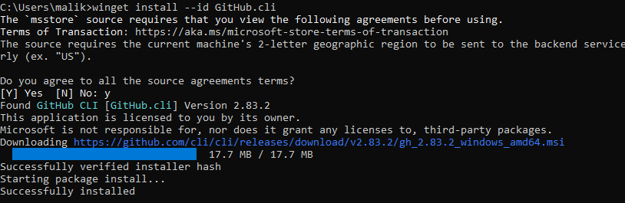
- (Local) Authenticate GH CLI for Codespaces:
gh auth login -s codespace
When prompted, generate a GitHub Access Token (classic) in the browser with the following Token scopes: admin:org, codespace, repo.
Copy the token into the GH CLI prompt to complete login
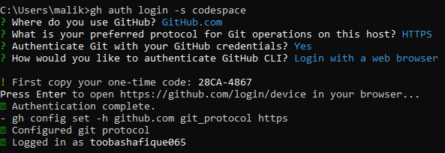
- (Local) List available Codespaces (optional verification):
gh codespace list
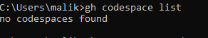
- (Local) Create or connect to a Codespace. To create a new codespace from the current repo:
gh codespace create --repo <owner>/<repo> --branch main --machine basicLinux32gb
Or to open an existing codespace:
gh codespace ssh -c <name_of_codespace>
gh codespace ssh -c fuzzy-bassoon-4jp7p65jj46p37pwv
After connecting via gh codespace ssh, you will be inside a Linux shell that the rest of this lab assumes.

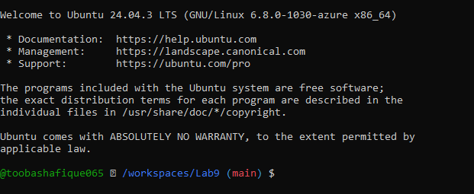

Task 2 — Install AWS CLI inside the Codespace and configure it
Goal: Install the AWS CLI in the Codespace and configure it to interact with your AWS account.
Inside the Codespace shell run:
- Download and install AWS CLI:
curl "https://awscli.amazonaws.com/awscli-exe-linux-x86_64.zip" -o "awscliv2.zip"
unzip awscliv2.zip
sudo ./aws/install
- Verify installation:
aws --version
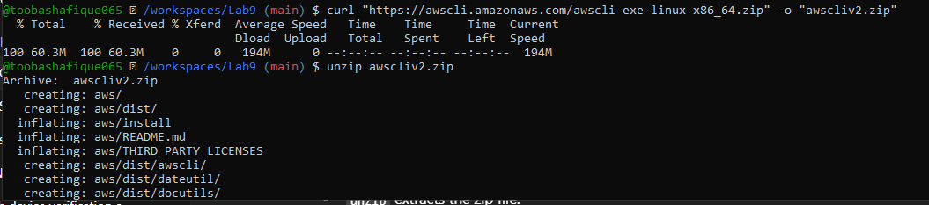
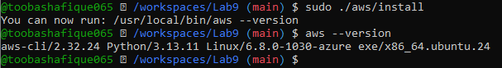
- Configure the AWS CLI (you will provide Access Key ID and Secret Access Key for a user with permissions, or use root/IAM user you prepared for the lab):
aws configure
Enter:
AWS Access Key ID:
AWS Secret Access Key:
Default region name (e.g., me-central-1)
Default output format (e.g., json)
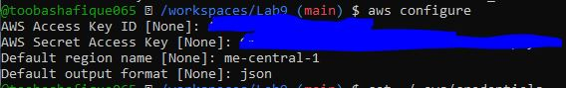
- Verify credentials/config files:
cat ~/.aws/credentials
cat ~/.aws/config
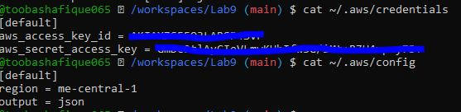
- Verify connectivity (you should see a JSON result showing your caller identity):
aws sts get-caller-identity
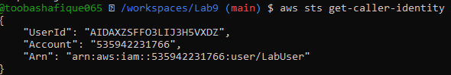

Task 3 — Create security group and add ingress rules using Codespace IP
Goal: Create an EC2 security group, inspect it, add an SSH rule for your Codespace public IP, and verify.
Steps (run in the Codespace shell):
- Create a security group (substitute your VPC id):
aws ec2 create-security-group --group-name 'MySecurityGroup' \
--description 'My Security Group' \
--vpc-id 'vpc-EXAMPLE1234567890'
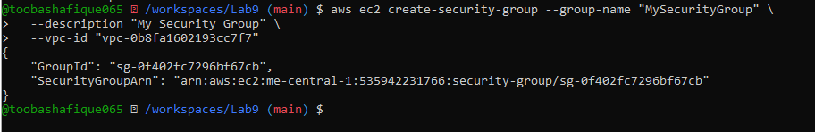
- Inspect the security group (initially ingress will be empty or default):
aws ec2 describe-security-groups --group-ids sg-EXAMPLE1234567890
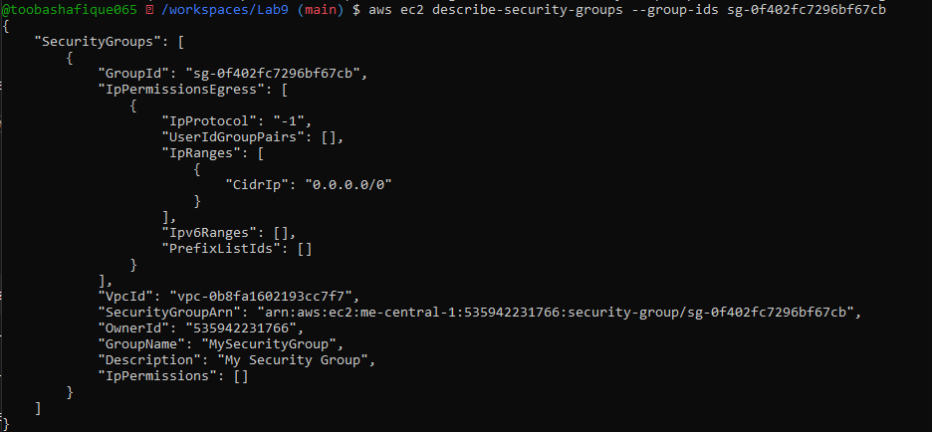
- Get your Codespace public IP (from inside the Codespace):
curl icanhazip.com
- Authorize SSH inbound on port 22 from your Codespace IP:
aws ec2 authorize-security-group-ingress \
--group-id sg-EXAMPLE1234567890 \
--protocol tcp \
--port 22 \
--cidr <XXX.XXX.XXX.XXX>/32

"GroupId": "sg-0f402fc7296bf67cb"
Ip : 4.240.39.193
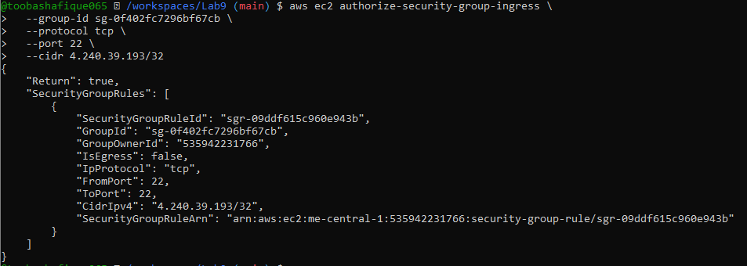
- Verify ingress rule appears:
aws ec2 describe-security-groups --group-ids sg-EXAMPLE1234567890
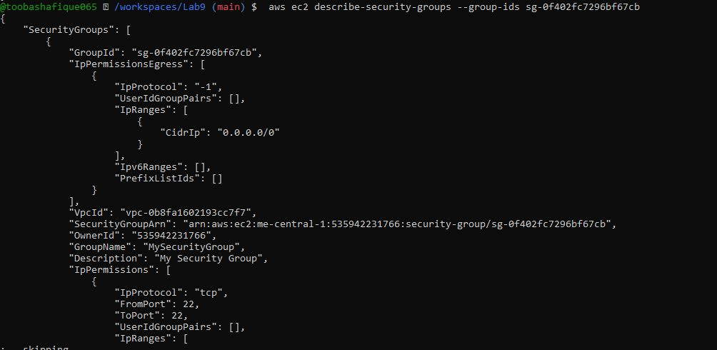
- Add an HTTP rule (port 80) using ip-permissions JSON:
aws ec2 authorize-security-group-ingress \
--group-id 'sg-EXAMPLE1234567890' \
--ip-permissions '{"FromPort":80,"ToPort":80,"IpProtocol":"tcp","IpRanges":[{"CidrIp":"<XXX.XXX.XXX.XXX>/32"}]}'
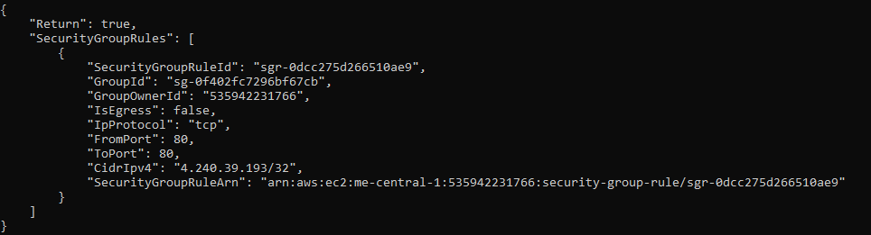
- Verify both ingress rules are present:
aws ec2 describe-security-groups --group-ids sg-EXAMPLE1234567890
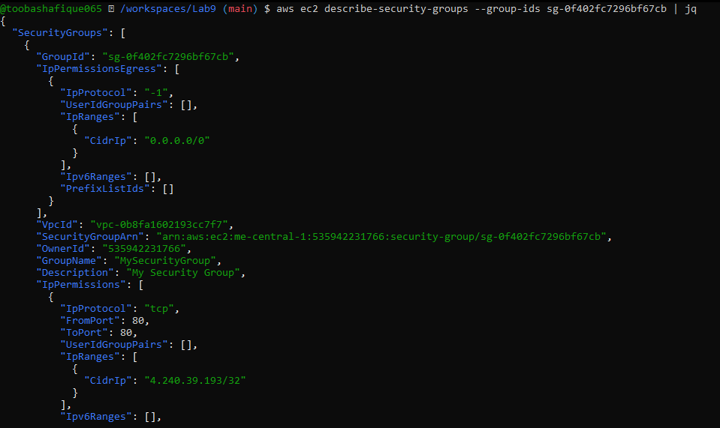

Task 4 — Create a key pair, describe key pairs, and launch EC2 instance
Goal: Create an ED25519 key pair, view it, and launch an EC2 instance using the key pair and the security group created earlier.
- Create the key pair and save the PEM file into the Codespace workspace:
aws ec2 create-key-pair \
--key-name MyED25519Key \
--key-type ed25519 \
--key-format pem \
--query 'KeyMaterial' \
--output text > MyED25519Key.pem
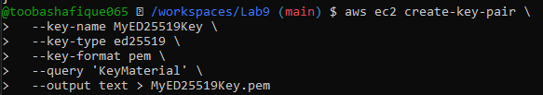
- View created key pairs:
aws ec2 describe-key-pairs
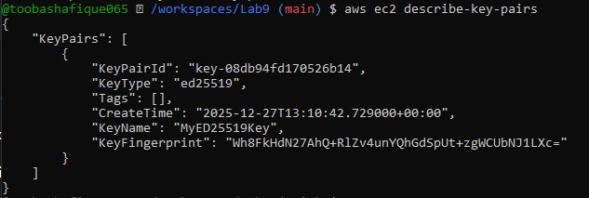
- (Do not) Delete key pair:
aws ec2 delete-key-pair --key-name MyED25519Key # Info: shows how to delete
- Launch an EC2 instance (example values — replace IDs with ones from your account/region):
aws ec2 run-instances \
--image-id ami-05e66df2bafcb7dea \
--count 1 \
--instance-type t3.micro \
--key-name MyED25519Key \
--security-group-ids sg-EXAMPLE1234567890 \
--subnet-id subnet-EXAMPLE1234567890 \
--tag-specifications "ResourceType=instance,Tags=[{Key=Name,Value=MyServer}]"

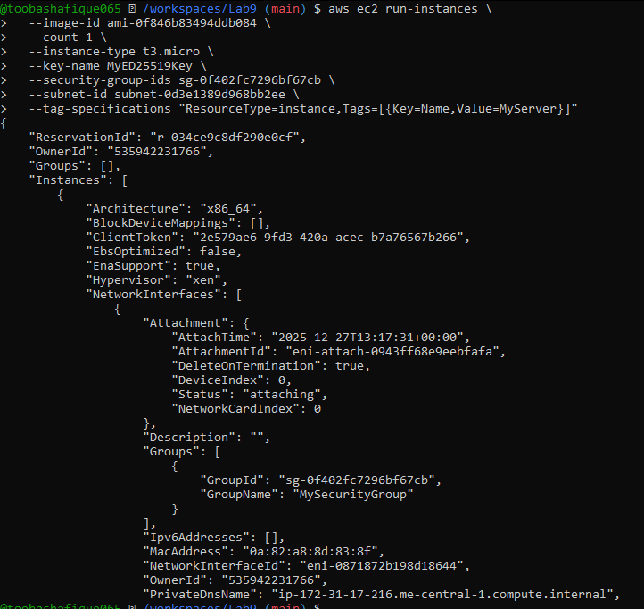
- Get the public IP address of your instance:
aws ec2 describe-instances \
--query "Reservations[*].Instances[*].[InstanceId,PublicIpAddress]" \
--output table
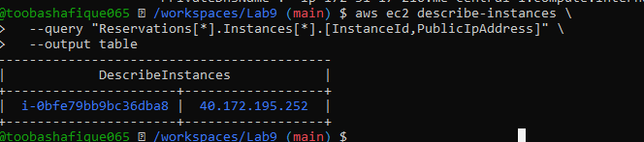
- Attempt SSH into the instance from the Codespace or from a machine whose IP is allowed in the security group:
ssh -i MyED25519Key.pem ec2-user@<public-ip-address>
If you see the error:
Permissions 0644 for 'MyED25519Key.pem' are too open.It is required that your private key files are NOT accessible by others.
fix permissions:
chmod 400 MyED25519Key.pem
ssh -i MyED25519Key.pem ec2-user@<public-ip-address>
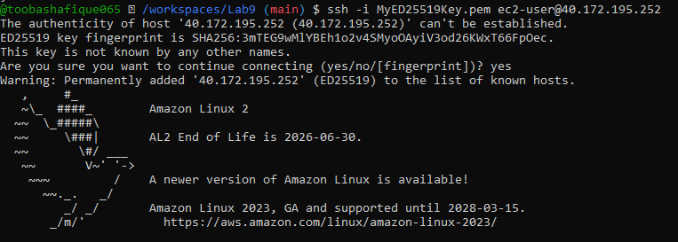
- Stop, start and (optionally) terminate the instance:
aws ec2 stop-instances --instance-ids i-EXAMPLE1234567890
aws ec2 start-instances --instance-ids i-EXAMPLE1234567890
aws ec2 terminate-instances --instance-ids i-EXAMPLE1234567890 # Don't run this command

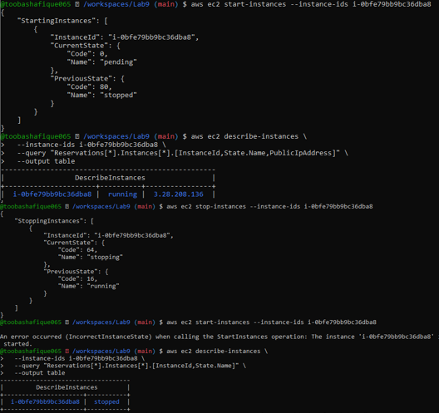

Task 5 — Understand AWS describe-* commands
Goal: Use describe commands to list and inspect AWS resources.
Run and understand these commands (run each, then capture screenshot immediately after):
aws ec2 describe-security-groups
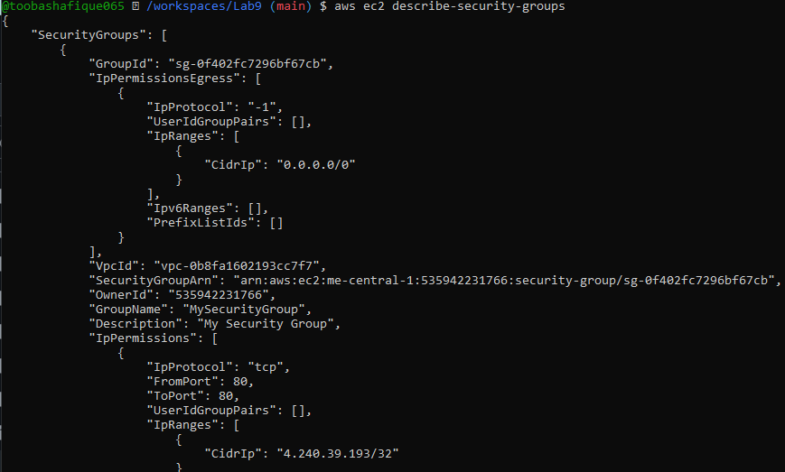
aws ec2 describe-vpcs
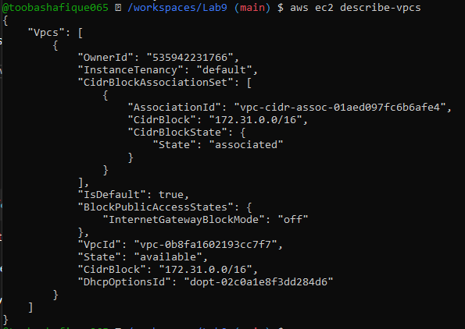
aws ec2 describe-subnets
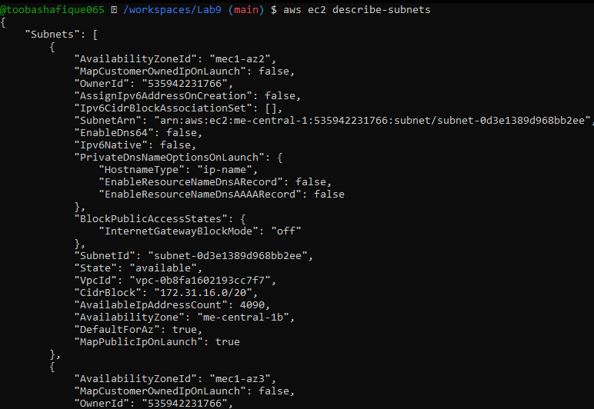

aws ec2 describe-instances
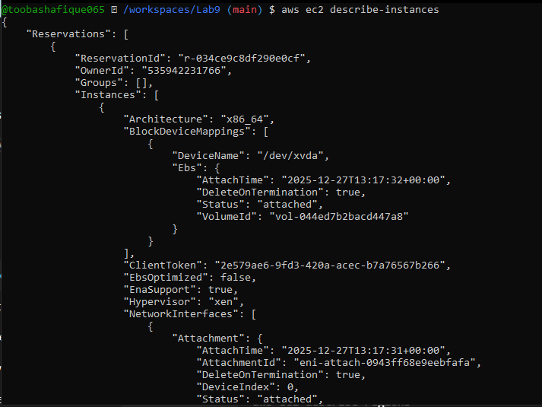
aws ec2 describe-regions
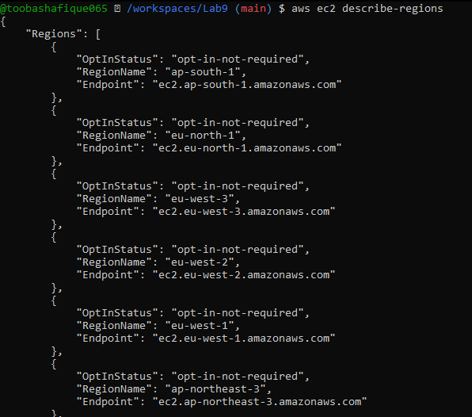
aws ec2 describe-availability-zones
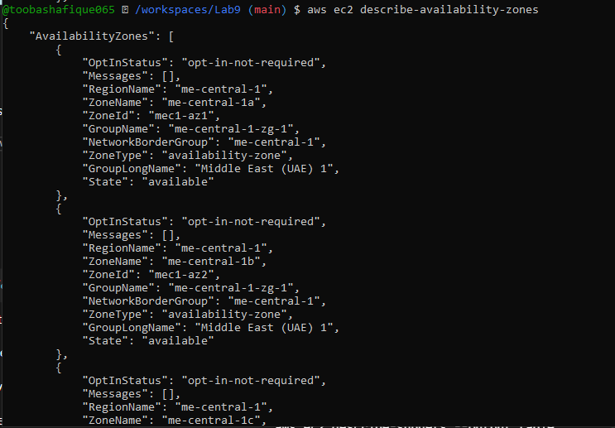

Task 6 — IAM: create group, user, attach policies, create console login & keys
Goal: Practice managing IAM via CLI: create group and user, attach policies, add user to group, create login profile, attach/detach change-password policy, create access keys, and test access via environment variables.
Commands and immediate screenshot request after each step:
- Create group: aws iam create-group --group-name MyGroupCli
- Get group details: aws iam get-group --group-name MyGroupCli
- Create user: aws iam create-user --user-name MyUserCli
- Get user details: aws iam get-user --user-name MyUserCli
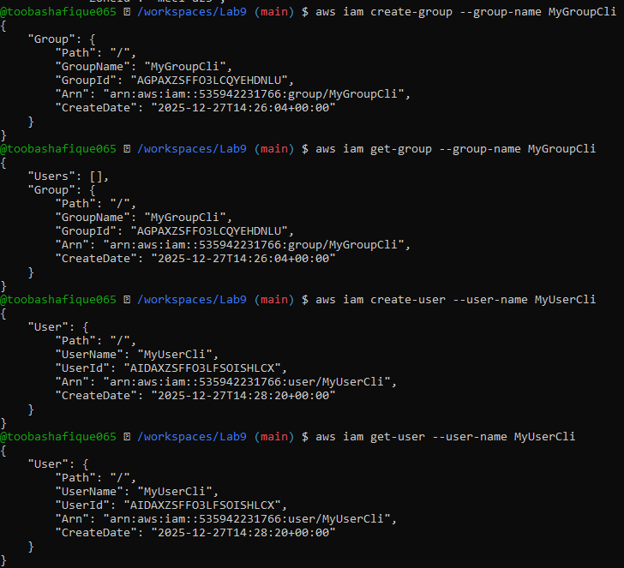
- Add user to group:
aws iam add-user-to-group --user-name MyUserCli --group-name MyGroupCli
See group again:
aws iam get-group --group-name MyGroupCli
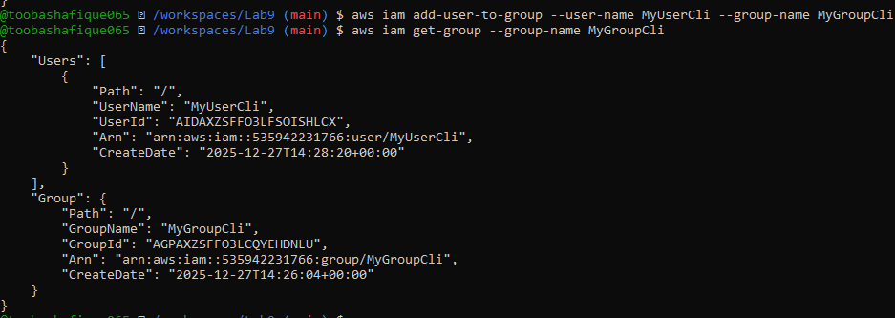
- List policies that mention EC2:
aws iam list-policies \
--query "Policies[?contains(PolicyName, 'EC2')].{Name:PolicyName}" \
--output text
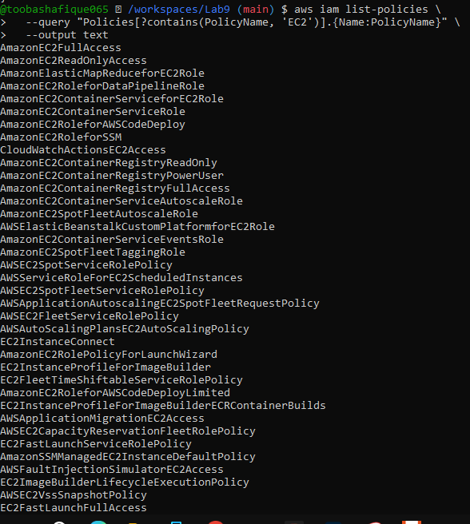
- Get ARN for AmazonEC2FullAccess (example query):
aws iam list-policies –query
'Policies[?PolicyName==`AmazonEC2FullAccess`].{Name:PolicyName, ARN:Arn}'
--output table
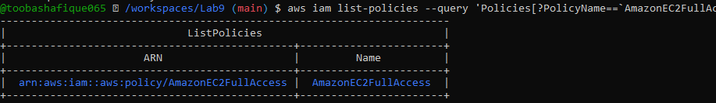
- Attach policy to group (use the ARN you retrieved):
aws iam attach-group-policy \
--group-name MyGroupCli \
--policy-arn arn:aws:iam::aws:policy/EXAMPLEPolicyName
- List attached policies for the group:
aws iam list-attached-group-policies --group-name MyGroupCli
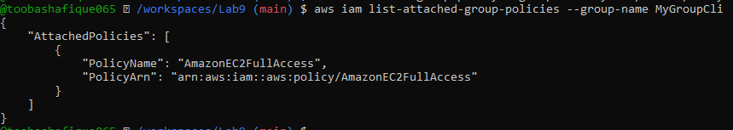
- Create a console login profile for the user:
aws iam create-login-profile \
--user-name MyUserCli \
--password <PASSWORD_VALUE> \
--password-reset-required
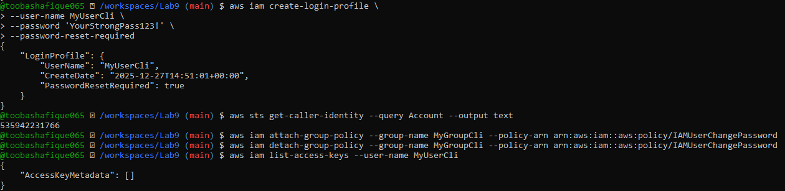
- If the user cannot change password, attach IAMUserChangePassword to the group temporarily:
aws iam attach-group-policy --group-name MyGroupCli --policy-arn arn:aws:iam::aws:policy/IAMUserChangePassword
After the user logs in and resets password, detach that policy:
aws iam detach-group-policy --group-name MyGroupCli --policy-arn arn:aws:iam::aws:policy/IAMUserChangePassword
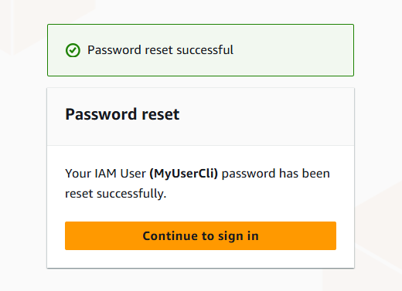
- Create access keys for the user (save AccessKeyId and SecretAccessKey securely):
aws iam create-access-key --user-name MyUserCli
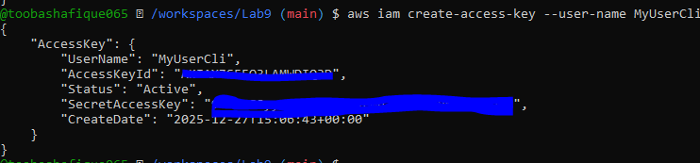
- List access keys:
aws iam list-access-keys --user-name MyUserCli
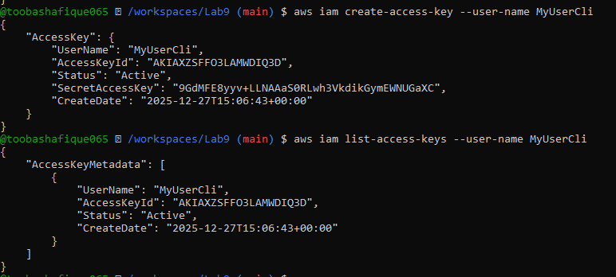
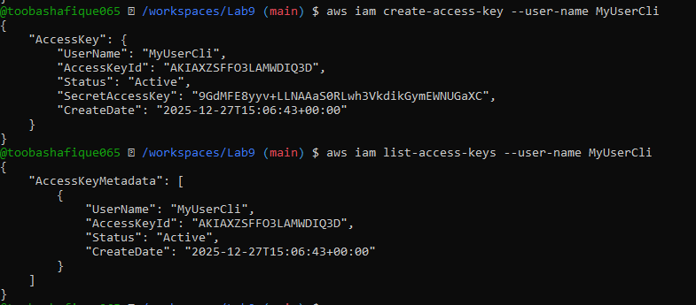
- (Don't) Delete access key:
aws iam delete-access-key --user-name MyUserCli --access-key-id <AccessKeyId> # Don't run this command
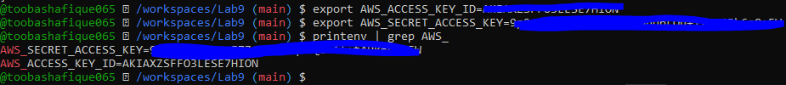
- After clearing or switching credentials, repeat get-user and save:
exit # to clear exports
aws iam get-user --user-name MyUserCli

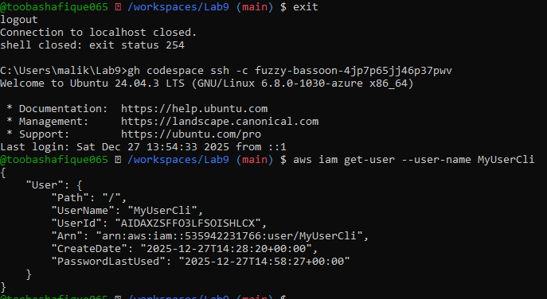

Task 7 — Filters: query with filters to find instances and their attributes
Goal: Use filters and queries to list specific instances and attributes.
aws ec2 describe-instances \
--filters "Name=tag:Name,Values=MyServer" \
--query "Reservations[*].Instances[*].PublicIpAddress" \
--output text
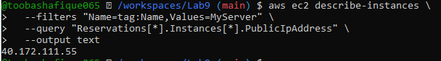aws ec2 describe-instances \
--filters "Name=instance-type,Values=t3.micro" \
--query "Reservations[].Instances[].InstanceId" \
--output table
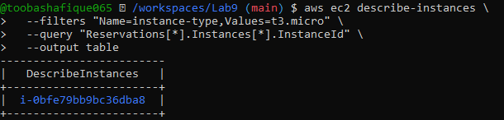
aws ec2 describe-instances \
--filters "Name=subnet-id,Values=subnet-0600df5fa8ce60857" \
--query "Reservations[*].Instances[*].InstanceId" \
--output table
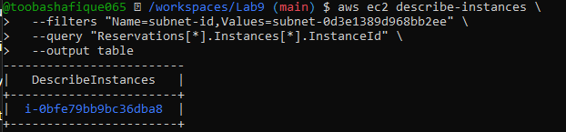
aws ec2 describe-instances \
--filters "Name=vpc-id,Values=vpc-06be85cd81b657192" \
--query "Reservations[*].Instances[*].InstanceId" \
--output table
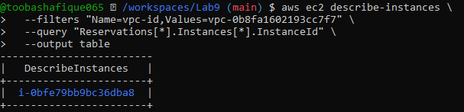

Task 8 — Use --query to format outputs for reporting
Goal: Extract useful fields in table format for reporting.
aws ec2 describe-instances \
--filters "Name=tag:Name,Values=MyServer" \
–query
"Reservations[*].Instances[*].[InstanceId,PublicIpAddress,Tags[?Key=='Name'].Value|[0]]" \
--output table
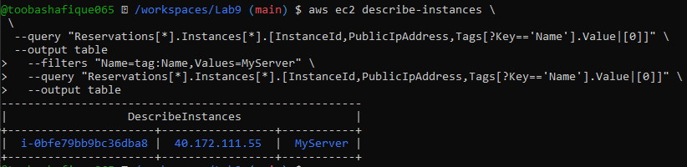
aws ec2 describe-instances \
--query "Reservations[*].Instances[*].[InstanceId,State.Name]" \
--output table
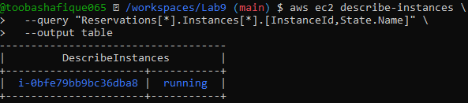
aws ec2 describe-instances \
–query
"Reservations[*].Instances[*].[InstanceId,InstanceType,Placement.AvailabilityZone]" \
--output table
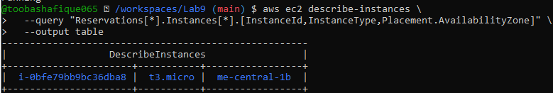

Cleanup — Remove resources to avoid charges
After verification, terminate and delete everything you created in AWS. Capture screenshots for each step.
- Terminate instances:
aws ec2 terminate-instances --instance-ids i-EXAMPLE1234567890
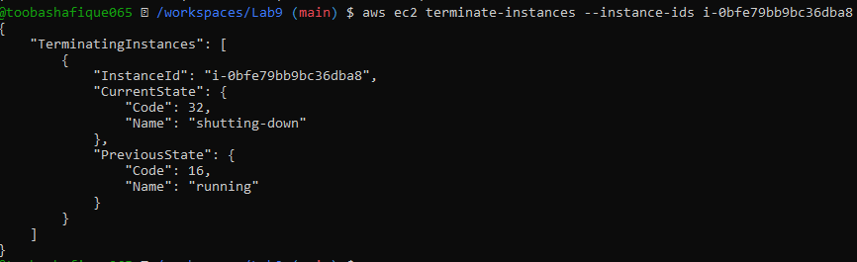
- Delete security group and key pair:
aws ec2 delete-security-group --group-id sg-EXAMPLE1234567890
aws ec2 delete-key-pair --key-name MyED25519Key
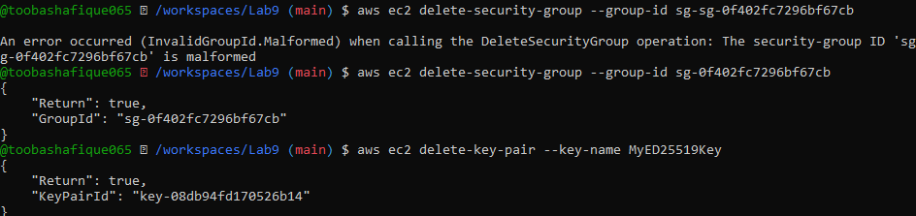
- Remove IAM users, access keys, groups:
aws iam delete-access-key --user-name MyUserCli --access-key-id <AccessKeyId>
aws iam delete-login-profile --user-name MyUserCli
aws iam remove-user-from-group --user-name MyUserCli --group-name MyGroupCli
aws iam delete-user --user-name MyUserCli
aws iam detach-group-policy --group-name MyGroupCli --policy-arn
arn:aws:iam::aws:policy/EXAMPLEPolicyName
aws iam delete-group --group-name MyGroupCli
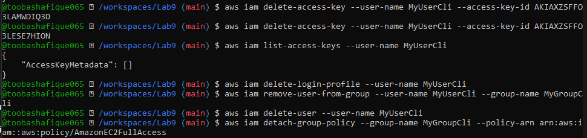
- Final verification (billing/resource groups)
